Bienfait 1970s:
A Personal Philatelic History

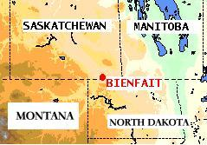

Bienfait got its name from Antoine Charles Bienfait

a member of a Dutch Banking Firm based in Amsterdam, Holland.

The Exhibit consists of some history of Bienfait, a photo of a
Bienfait Post Office Sign, a few first day issues, and some Bienfait cancellations. The exhibit is based on covers and cancels that were associated with my father . He was the only physician in Bienfait in this time. The covers and cancels are from mail sent to Dr Rennie after he left Bienfait in 1969.

History

Canadian Pacific Rail came to Bienfait August 1, 1892. Lignite Coal was discovered in 1904. Canadian Northern Railway came in 1909. During the prohibition days Paul Matoff was murdered in the CPR Station. There was the 1931 Miner's Strike where three Miners were killed by the RCMP.

The First Post Office opened on the 1st of April, 1893, closing the 22nd of February, 1895. It reopened December 1st, 1903.

In 1903 the Post Office was at Kupchenko's Farm. It was later located on the East side of Main Street from 1906 to 1956. Then a fire occurred and the Post Office was moved to the West side (1956 to 1971). See picture below.

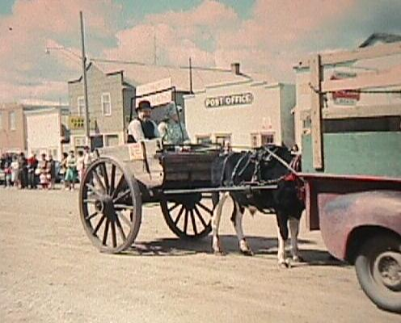

In the Early 1950s the Post Office was robbed. The Safe was about three feet square.

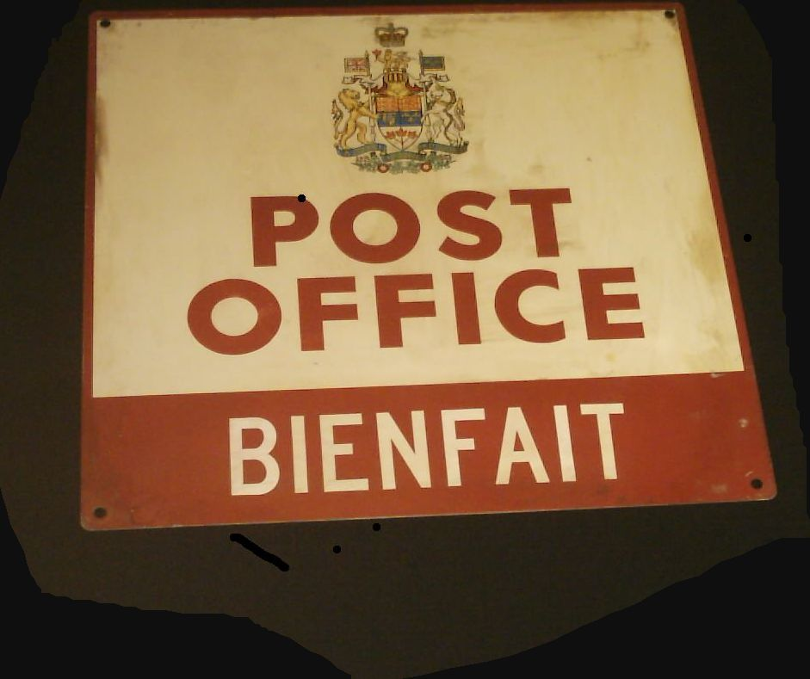

I acquired this sign around 1996 at MacGowan’s Oldware’s & Antiques in Saskatoon.

The top part of the sign has the Arms of Canada, which has the Shield, Helm and Mantling, Crest, Supporters, and Crown.

On the next Page is a first day issue for the Canadian stamp of Doctor Banting's contribution to the discovery of Insulin. It was sent to doctors in North America along with promotional material for Elliott/Marion pharmaceuticals.

